

Story 1

Temperature interval violation

Version 0.1

15. 11. 2005

Your partner to set your business into real-time

Table of contents

Story 1 1
Table of figures 2
1 Starting point 3
2 Preperation 3
3 The Transport 3
4 Acceptance of Shipment 4
5 Conclusion 4

Table of figures

Figure 1: Eventdiagram 5
Figure 2: Storyline 6

- Starting point
The Spanish depot in Madrid estimates that the lower limit for the product “Arzeutic” will be reached on Monday, November 14, 2005. Therefore they ask on October 31, 2005 for a shipment of 700 units until November 12, 2005.

In Vienna the order is checked in and accepted as OrderId 14765. Vienna takes care of the next steps to fulfill the order accurately. (OrderReceived, OrderConfirmed)
- Preperation
In a first step a carrier has to be picked, which is able to carry out the shipment under the following constraints (ShipmentTenderIssued):

- Departure from central storage depot in Vienna on November 7, 2005 morning
- Arrival in depot Madrid until November 12, 2005
- Price lower or equal to 2500EUR

Additionally the product “Arzeutic” needs special treatment during the shipment: to ensure the full quality of the product, it has to be kept in a temperature interval between 3°C and 8°C.

The carriers Anger(532) and Fischer(142) have to refuse the shipment, because of lacking capacity. Carrier Weiss (432) accepts the shipment. (ShipmentTenderRejected, ShipmentTenderAccepted)

A schedule for the shipment is created together with carrier Weiss. The shipment will take two stages: Stage 1 from Vienna to Munich, stage 2 from Munich to Madrid. The transport is planned to start on November 7, 2005 08:15 from Vienna and to finish on November 10, 2005 08:00 in Madrid. Earliest possible date the central storage depot in Vienna can provide 700 units “Arzeutic” is November 6, 2005 16:00. Until November 12, 2005 06:00 the truck must reach Madrid to avoid shortcomings of the product in Spain.
It is necessary to monitor the temperature of “Arzeutic” during the whole transport. For this reason two dataloggers are configured to protocol the current temperature every 60 minutes. The dataloggers are packed together with the products to determine the values as exact as possible. (DataLoggerConfigured)
- The Transport
On November 7, 2005 08:15 the transport goes of as planned from central storage depot in Vienna. Carrier Weiss drives off at 08:20 and reaches the destination of the first stage, Munich, at 16:07. (ShipmentStarted, TransportStart, TransportEnd)

The products are handed over to the carrier’s depot in Munich. Dataloggers are checked and the shipment is audited for its completeness. The values are sent into the system, where they are recognized as valid values. (DataLoggerRead, ShipmentAudit)

Next morning, November 8, 2005 06:30 carrier Weiss continues the transport on stage 2 as planned. (TransportStart)

- Acceptance of Shipment
On November 9, 2005 14:32 the destination is reached, and the products are handed over to the depot in Madrid. Everything looks like a trouble-fee shipment: The planned delivery date was even beaten, and no difficulties during transport arose. (TransportEnd)

However when reading the Dataloggers, the system recognizes a violation of the valid temperature interval (3°C to 8°C) during the transport from November 7, 16:20 till November 8, 07:00. Obviously the shipment was not accurately handled in the carrier’s depot during stage 1 and stage 2 – it got to warm. (DataLoggerRead)

The product’s quality can’t be guaranteed under these circumstances. The shipment of OrderId 14765 must be tagged as „failure“. Thus 700 units of “Arzeutic” are missing in the spanish depot; the lower limit will be under-run on November 14, 2005. (ShipmentDelivered)

To avoid an escalation of the situation, a new high-priority shipment must be triggered immediately, that reaches Madrid until November 14, 2005.
- Conclusion
The system could not just recognize the faulty delivery, it could also trigger a new shipment automatically to minimize time losses and ensure an in-time delivery in spite of all obstacles.

Figure 1: Eventdiagram

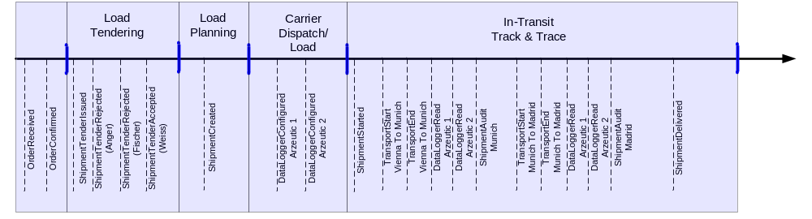

Figure 2: Storyline

OrderReceived.DeliveryDate
Transport Vienna - Munich
Transport Munich - Madrid
Violation of temperature interval recognized
Message
Shipment failed
Trigger new order
…
OrderReceived
DataloggerRead
DataloggerRead
Valid temperature:
3°C – 8°C
Violation of temperature interval

